TY IT-1(BATCH A)

DCDR
150410116018

DESAI JAIMIN

Extra Practical: Study of Compression tool and analysis of time and space complexity and compression ratio.

Folder 1 :(Images) Original size: 254803968 bytes(248832KB)

Compression Time: 15 seconds

Compressed file: RAR size: 35546726.4 bytes(34713.6KB)

Compression Ratio (%) : ( 1 – Compressed size of file/ (Original Size))*100

(1-33.9/243)*100 = 86.049%

Folder 2 :(Audio) Original size: 1.31 MB (1,374,386 bytes)

Compression Time: 3 Seconds

Compressed file: RAR size: 1.29 MB (1,358,063 bytes)

Folder 3(Text files): Original size: 991952896 bytes (968704KB)

Compression Time: 4 minutes 15 seconds

Compressed file: RAR size: 574619648 bytes (561152 KB)

Compression Ratio (%) : 1-(548/946)*100 = 42.072%

SVIT - VASAD Page 1

TY IT-1(BATCH A)

DCDR
150410116018

DESAI JAIMIN

Pratical 1:-Write a program to get frequency count of all symbols in a file.

File :-f1.txt

Sardar vallbhbhai patel institute of technology

Program:

#include<stdio.h>

void main()

{

FILE *f;

char c;

int count[26]={0};

int x,i;

clrscr();

f=fopen("f1.txt","r");

while(c!=EOF)

{

c=getc(f);

x=c-97;

count[x]++;

}

for(i=0;i<26;i++) {

if(count[i]!=0)

printf("\n %c \t %d times",i+97,count[i]);

}

fclose(f);

getch();

}

SVIT - VASAD Page 2

TY IT-1(BATCH A)

DCDR
150410116018

DESAI JAIMIN

OUTPUT:

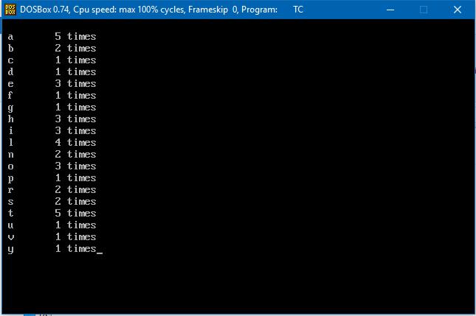

SVIT - VASAD Page 3

TY IT-1(BATCH A)

DCDR
150410116018

DESAI JAIMIN

Practical 2:- Write a program to calculate self information and entropy if probabilities are given.

Program:

#include<stdio.h>

#include<conio.h>

#include<math.h>

void main()

{

int i,c;

float p,sum=0,it;

float selfin[50];

clrscr();

printf("Enter No of Messages:");

scanf("%d",&c);

for(i=1;i<=c;i++)

{

printf("Enter the probability for %d Message\t:",i);

scanf("%f",&p);

selfin[i]=(log(1/p))/log(2);

printf("Self Info:%f\n",selfin[i]);

it=p*(log(1/p))/log(2);

sum=sum+it;

}

printf("Entropy of the Given Messages:%f",sum); getch();

}

SVIT - VASAD Page 4

TY IT-1(BATCH A)

DCDR
150410116018

DESAI JAIMIN

Output:

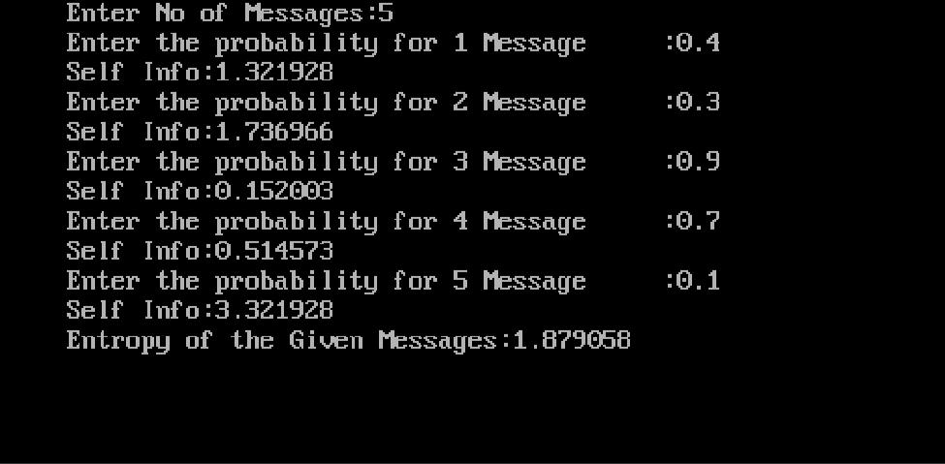

SVIT - VASAD Page 5

TY IT-1(BATCH A)

DCDR
150410116018

DESAI JAIMIN

Practical 3:-Write a program to calculate average length if probabilities and codes are given.

Program:

#include<stdio.h>

#include<conio.h>

#include<string.h>

void main()

{

char str[50][50],c[50];

float prob[50];

int len[50],i=0,n=0;

float avglen=0;

clrscr();

printf("Enter number of th character:");

scanf("%d",&n);

printf("\nEnter the code and Probabilities for each character:\n");

for(i=0;i<n;i++)

{

printf("\n%d->Charater:",i+1);

scanf("%s",&c[i]);

printf("\n\t->Code:");

scanf("%s",&str[i]);

len[i]=strlen(str[i]);

printf("\n\t->Length:%d",len[i]);

SVIT - VASAD Page 6

TY IT-1(BATCH A)

DCDR
150410116018

DESAI JAIMIN

printf("\n\t->Probability:");

scanf("%f",&prob[i]);

avglen=avglen+(prob[i]*len[i]);

}

printf("\n\nAverage Length is: %f",avglen);

getch();

}

Output:

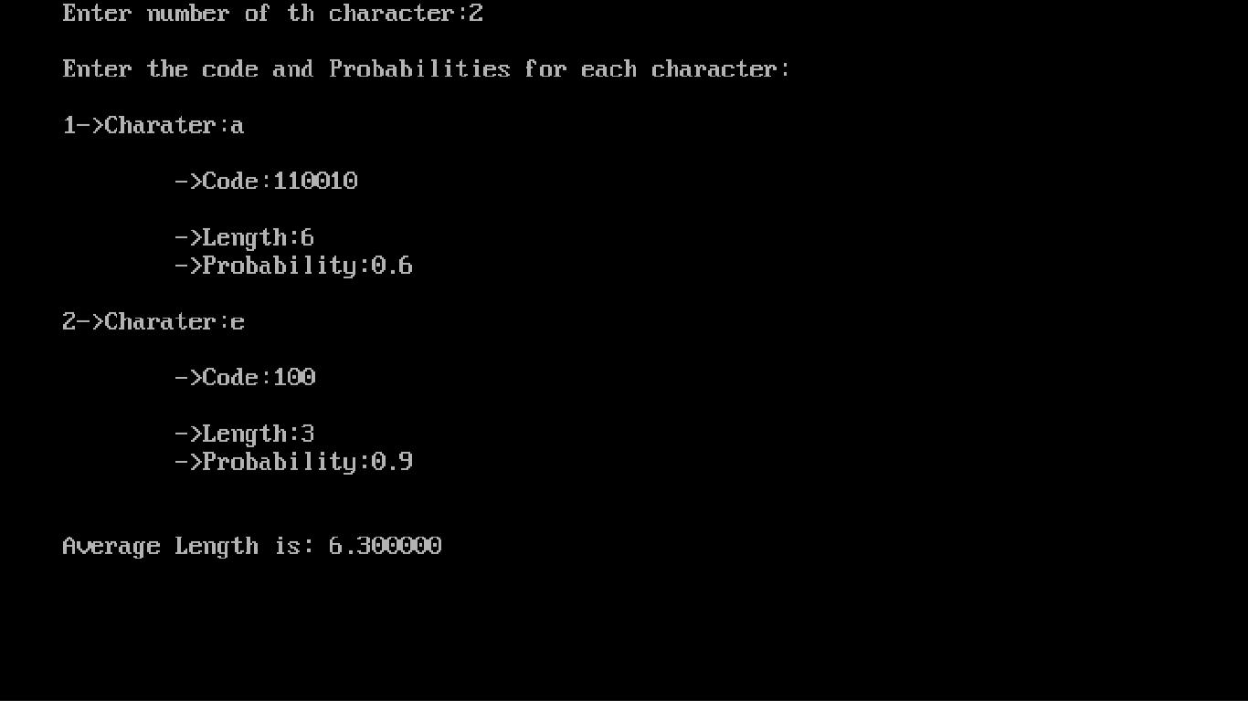

SVIT - VASAD Page 7

